Wasdin Lab 2
Map 1- https://tamu.maps.arcgis.com/apps/mapviewer/index.html?webmap=b2c3b4df460c4a429ea50d4c4ecd2e82
Map 2- https://tamu.maps.arcgis.com/apps/mapviewer/index.html?webmap=a6e66fe342104951808b82074b29d2b4
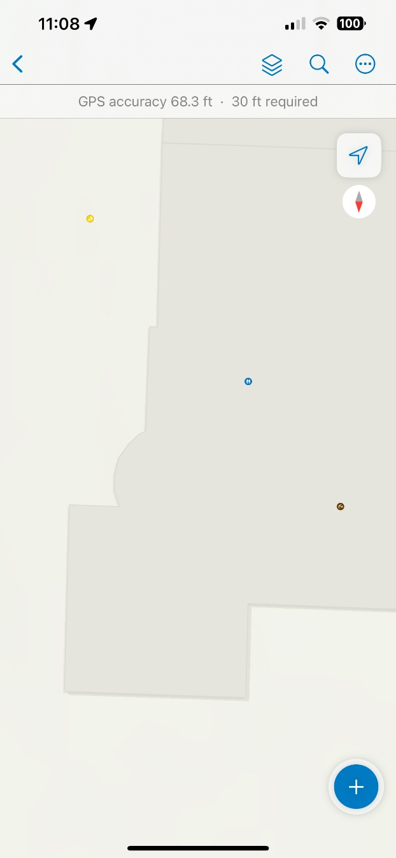
Screenshot from Field Maps-

